Set 2
f, g, n, ò, ù
Sound - f
Associated word/phrase – Ma tha thu falbh, na fàg dad.
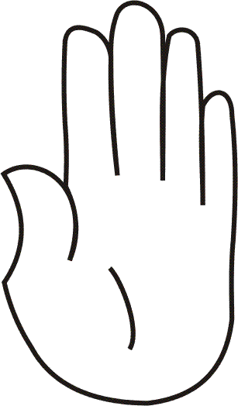 | Point your finger
 | Say f f f f as in “flower”
 | Write f in the air with your finger

Sound - g
Associated word/phrase – Goc gàg goc gàg tha ugh agam dhut an dràst’.
Flap your arms like a chicken flapping its wings
Say g g g g as in “good”

Write g in the air with your finger

Sound - n
Associated word/phrase – Tha càr nam Poileis a’ dol nà no nà no nà no.
Move your hand on top of your head like a flashing light.
Say n n n n as in “door”
Write n in the air with your finger

Sound - ò
Associated word/phrase – mòr
Hand over your head showing someone taller than you
Say ò ò ò ò (the accent on the o lengthens the sound)
Write ò in the air with your finger

Sound - ù
Associated word/phrase – cù
Wave your hand at the base of your back like a dog wagging its tail
Say ù ù ù ù as in “boo”
Write ù in the air with your finger

