Set 3
b, th, mh, sh, ao

Sound - b
Associated word/phrase – bò
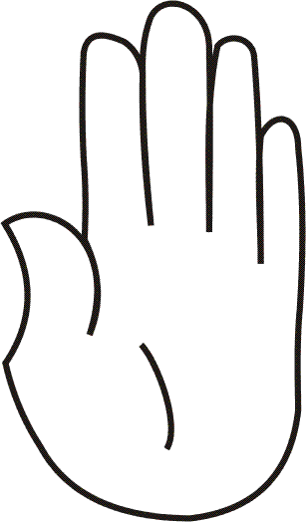 | Make horns with your fingers on your head like a cow
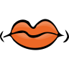 | Say b b b b as in “boo”
 | Write b in the air with your finger

Sound - th (h)
Associated word/phrase – Thairis a’ bhalla.
Action jumping over a wall with your hand
Say th th th th as in “hair”
Write th in the air with your finger

Sound - mh (v)
Associated word/phrase – làmh
Hold one hand up
Say mh mh mh mh as in “van”

Write mh in the air with your finger

Sound - sh (h)
Associated word/phrase – shad mi an ad
Move your hands as if you are throwing a hat
Say sh sh sh sh as in “hair”
Write sh in the air with your finger

Sound - ao
Associated word/phrase – aon
Hold up one finger
Say ao ao ao ao like you think something’s yucky!
Write ao in the air with your finger

